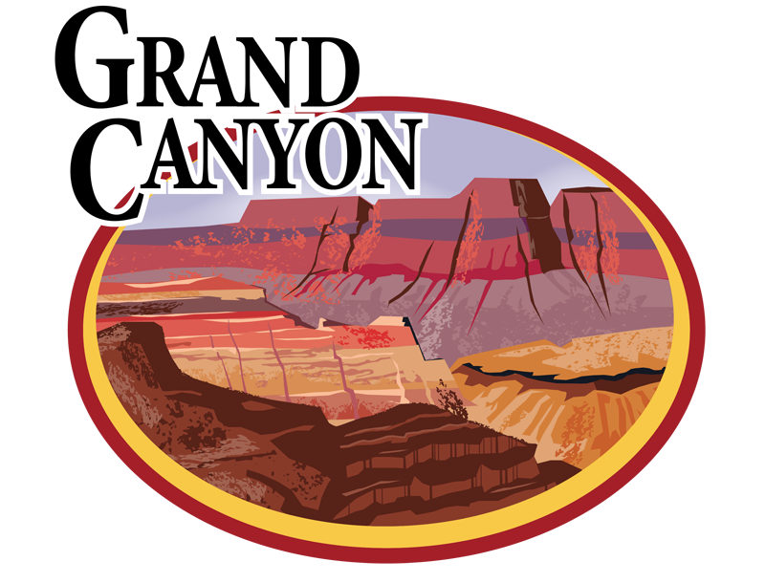

Hello Parents!

I am excited to announce that I will be taking our 7th and 8th grade students to the Grand Canyon on November 20th! This will be an all day trip including an educational tour guided by a Grand Canyon Park Ranger.

We will hold our 1st Parent Information Meeting **NEXT WEDNESDAY** September 23, at 3:30 in the 7th grade classroom. Please make your best effort to attend if your student is interested in participating in this field trip.

I am also looking for around 5 chaperones to attend as well, please let me know if you would be interested. If you are unable to attend this meeting but are still interested, please contact me via email at: [cdavidson1@cardenoftucson.org](mailto:cdavidson1@cardenoftucson.org).

There will be a cost to this trip; however, it cannot be correctly calculated until there is a set number of participating students and chaperones.   
Scholarships will potentially be available for those who wish to attend but are concerned about costs, please speak to Ms. Davidson for further information.

Fundraising is a great option to aid in lowering the costs for students and chaperones as well as potentially covering those costs, and I am open to suggestions on fundraising ideas.

At this meeting, you will receive a tentative schedule and a potential cost as well as be able to ask any questions you have regarding this trip.   
There will also be a sign up sheet at this meeting for those who are interested in attending.

I’m looking forward to seeing all of you!

-Ms. Davidson